Testing Report: Tiny Box Challenge 2020

Competitor Name:

- Experimental Measurements

Parameter | Measured Value
Dimensions of Rectangular Enclosure | 2 in x 2 in x 1 in
Volume of Rectangular Enclosure | 4 in³
Power Density at 12W out | 15 W/in³
Efficiency @ P_{out} | 75% @ 3W  80% @ 6W  95% @ 9W  98% @ 12W
TPE Efficiency | 92.2%
No-load Power Losses | 2W
Input Voltage Ripple | 1%

- Converter Schematic

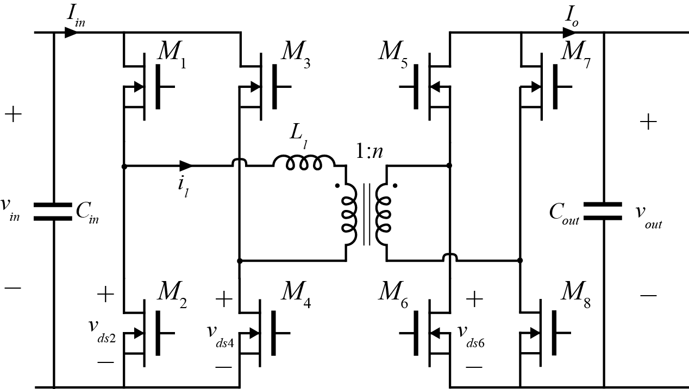
Fig.1: Converter Schematic
- Converter Parameters
Parameter | Value
L_{l} | 10 μH
C_{in} | 5 μF
C_{out} | 10 μF
n | 0.08
f_{s} | 1 MHz

- Component Implementation
Component | Implementation
L_{l} | 2107-V-RC
M₁-M₄ | EPC2004  LM5121 Gate Driver
M₅-M₈ | EPC2004  LM5121 Gate Driver
Transformer | Ferroxcube 3F3  ER2312  primary: 10 turns 20AWG  secondary: 3 turns 10 AWG
C_{in} | B32524Q1156K
C_{out} | 2x B32524Q1156K

- Converter Waveforms
Note: for each waveform, include the specified measured voltages/currents with sufficient scale to see all salient features. Include between two and four complete switching periods.
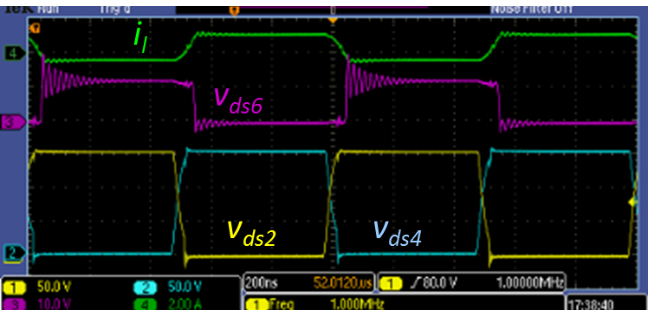
Fig. 2: General converter waveforms (e.g. switching nodes, inductor currents, etc. Label each waveform corresponding to a label in Fig. 1)
Fig. 3: Input current and input voltage at full power
Fig. 4: Output current and outptut voltage at full power

- Photographs

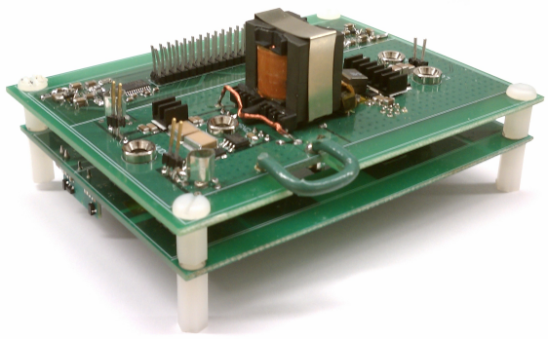
Fig. 5: Prototype Converter picture

